**IT2120 – Probability and Statistics**

**Lab Sheet 10**

IT24102891

Aththanayaka A.M.S.N

1)

i)

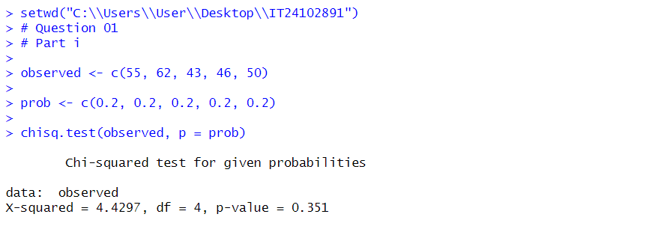

ii)

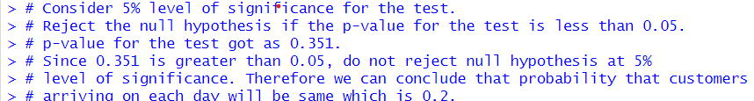

2)

i)

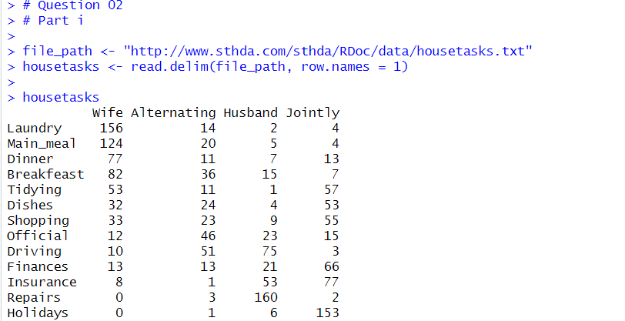

ii)

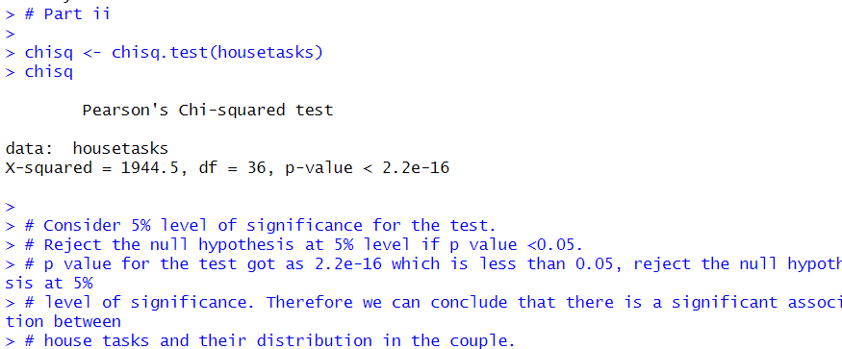

Exercise:

